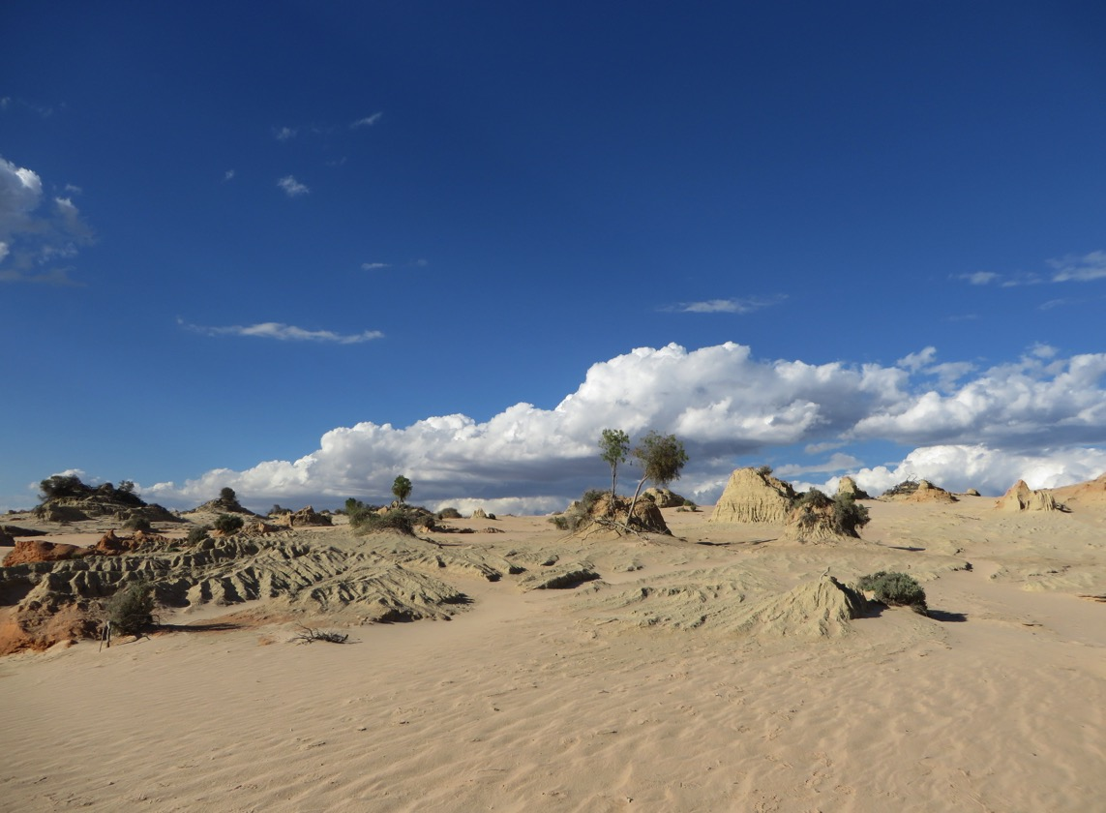

Yingadi Immersion 2018

***Yingadi*** *– meaning to come/be invited*

*You are invited to come,*

*experience the ancient sands*

*at Lake Mungo.*

*Black feet, white feet,*

*walking together in harmony with the land.*

*Touching the sacredness of Aboriginal spirituality.*

*Feel the presence of my old people.*

*When you walk with me I feel proud,*

*I feel strong as a Mutthi Mutthi woman.*

*Vicki Clark.*

**When: Monday 26th February to Friday 2nd March 2018**

**Leaving from Amberley – Lower Plenty**

***and***

**Monday 13th to Friday 17th August 2018**

**Leaving from Sandhurst Diocese – Bendigo or Shepparton**

**Cost:** $1200 all inclusive (transport, accommodation, meals)

**Expression of Interest and Application:**

**Karen Mahoney – Yingadi Immersion Coordinator:** yingadi@edmundrice.org

**Phone:** 8359 0141

Mobile: 0439 290 410

***Yingadi*** *is offered through the Christian Brothers Oceania Province*

*in partnership with Vicki Clark – Yingadi Inc.*