Special Ceremony to Celebrate
Mungo Man Spiritual Journey Home
Friday 17th of November 2017

Clapsticks – to call all to prayer or didgeridoo music

Reader: Today we celebrate one of the most sacred moments in our Reconciliation journey. The world’s most famous Australian treasure Mungo Man is coming home. Mungo Man was removed from his burial site in 1974 without permission from the local traditional Aboriginal custodians. The sacredness of returning this Man cannot go unnoticed. So let us join with the Traditional Owners in spirit and prayer on the lands of……….. (Acknowledge the lands that you are on)

Sign of the Cross
In the name of the Father and of the Son and of the Holy Spirit.
Amen
Reflection:
Reader: Consider for a moment the thoughts of those mourners at the grave 42,000 years ago. They had gone to great lengths to gather the precious mineral ochre, to grind and spread it on the body. Alongside the grave a large fire sent smoke swirling through the mourners. There was obviously something very special about this man, a father, a leader of his community. Consider the tears, the sadness as final layers of sand were spread over the sleeping body. Little could those people ever imagine that body would emerge again at the earth's surface, to surprise and educate people more than 1000 generations later?

Reader introduces footage:
Reader: Let us listen now to a short story to help us understand the significance of today.
Watch link below as an introduction starting .43 seconds mark the footage goes for about for about 4 minutes in total
https://www.welcometocountry.org/mungo-man-set-to-make-final-spiritual-journey-home/
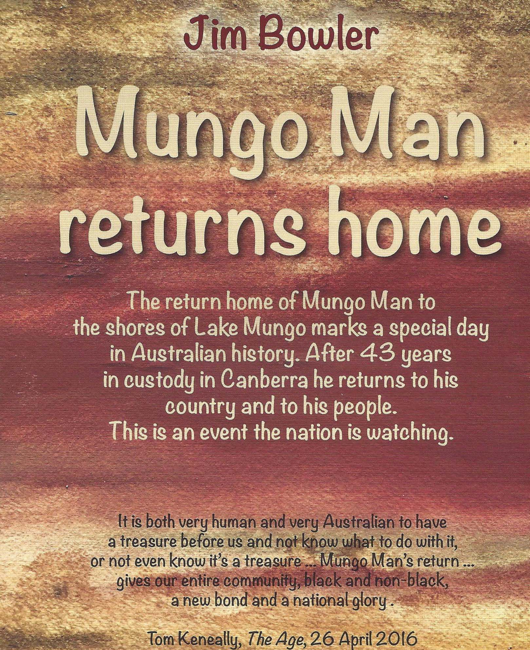 look for this image

Opening Prayer:
Heavenly Father, the stories of the Hebrew people whose covenant with you we have inherited, are stories of the relationship between You, Your Chosen people and the Land. Today we remember the sacredness of the land to Your First Peoples in both life and death. We now ask for your blessing on Mungo Man and his descendants.
We ask this through Christ Our Lord,

AMEN

Reader: Let us now listen to the Word of the prophet EZEKIEL:
Adapted by the Aboriginal Catholic Ministry for Victoria

I felt the powerful presence of the Creator; He took me and sat me down in a sacred place where the ground was covered with bones. The Creator led me through this ancient burial site to the sacred hills. I could see that there were very many bones and that they were very dry. The Creator said to me: "Can these bones come back to life?" I replied: "Creator Spirit, only You can answer that."

The Creator said: "Speak to the bones; tell these dry Bones to listen; tell them that I am speaking to them. I 'm going to put breath into you and bring you back to life. I will give you sinews and muscles and cover you with skin. I will put breath into you and give you back the life you had before. Then you will know I am the Creator."

So I spoke as I had been told. While I was speaking, I heard a rattling noise and the bones began to join together. While I watched, the bones were covered with sinew, muscles and then skin, but there was no breath in the bodies.

The Creator said to me: "Speak to the wind and tell the wind that the Spirit calls it from every direction to breathe into these bodies and to bring them back to life."
So I spoke as I had been told and breath entered the bodies and they came to life and stood up.

The Creator said to me: "Your people are like these bones. They say that they are dried up without any hope and without future. So speak to my people and tell them that I, the Creator, will uncover their bones and bring them back to their own inherited land. When I uncover the place where my people are buried and bring them back, their presence in this land will be revealed. I will put my breath in them. They will have the life they had before. The will live in the land where there is justice and truth. Then everyone will know that I am the Creator. I have promised that I would do this, and I will."

Instrumental Response:
https://itunes.apple.com/us/artist/anne-maree-higgins/id950889756
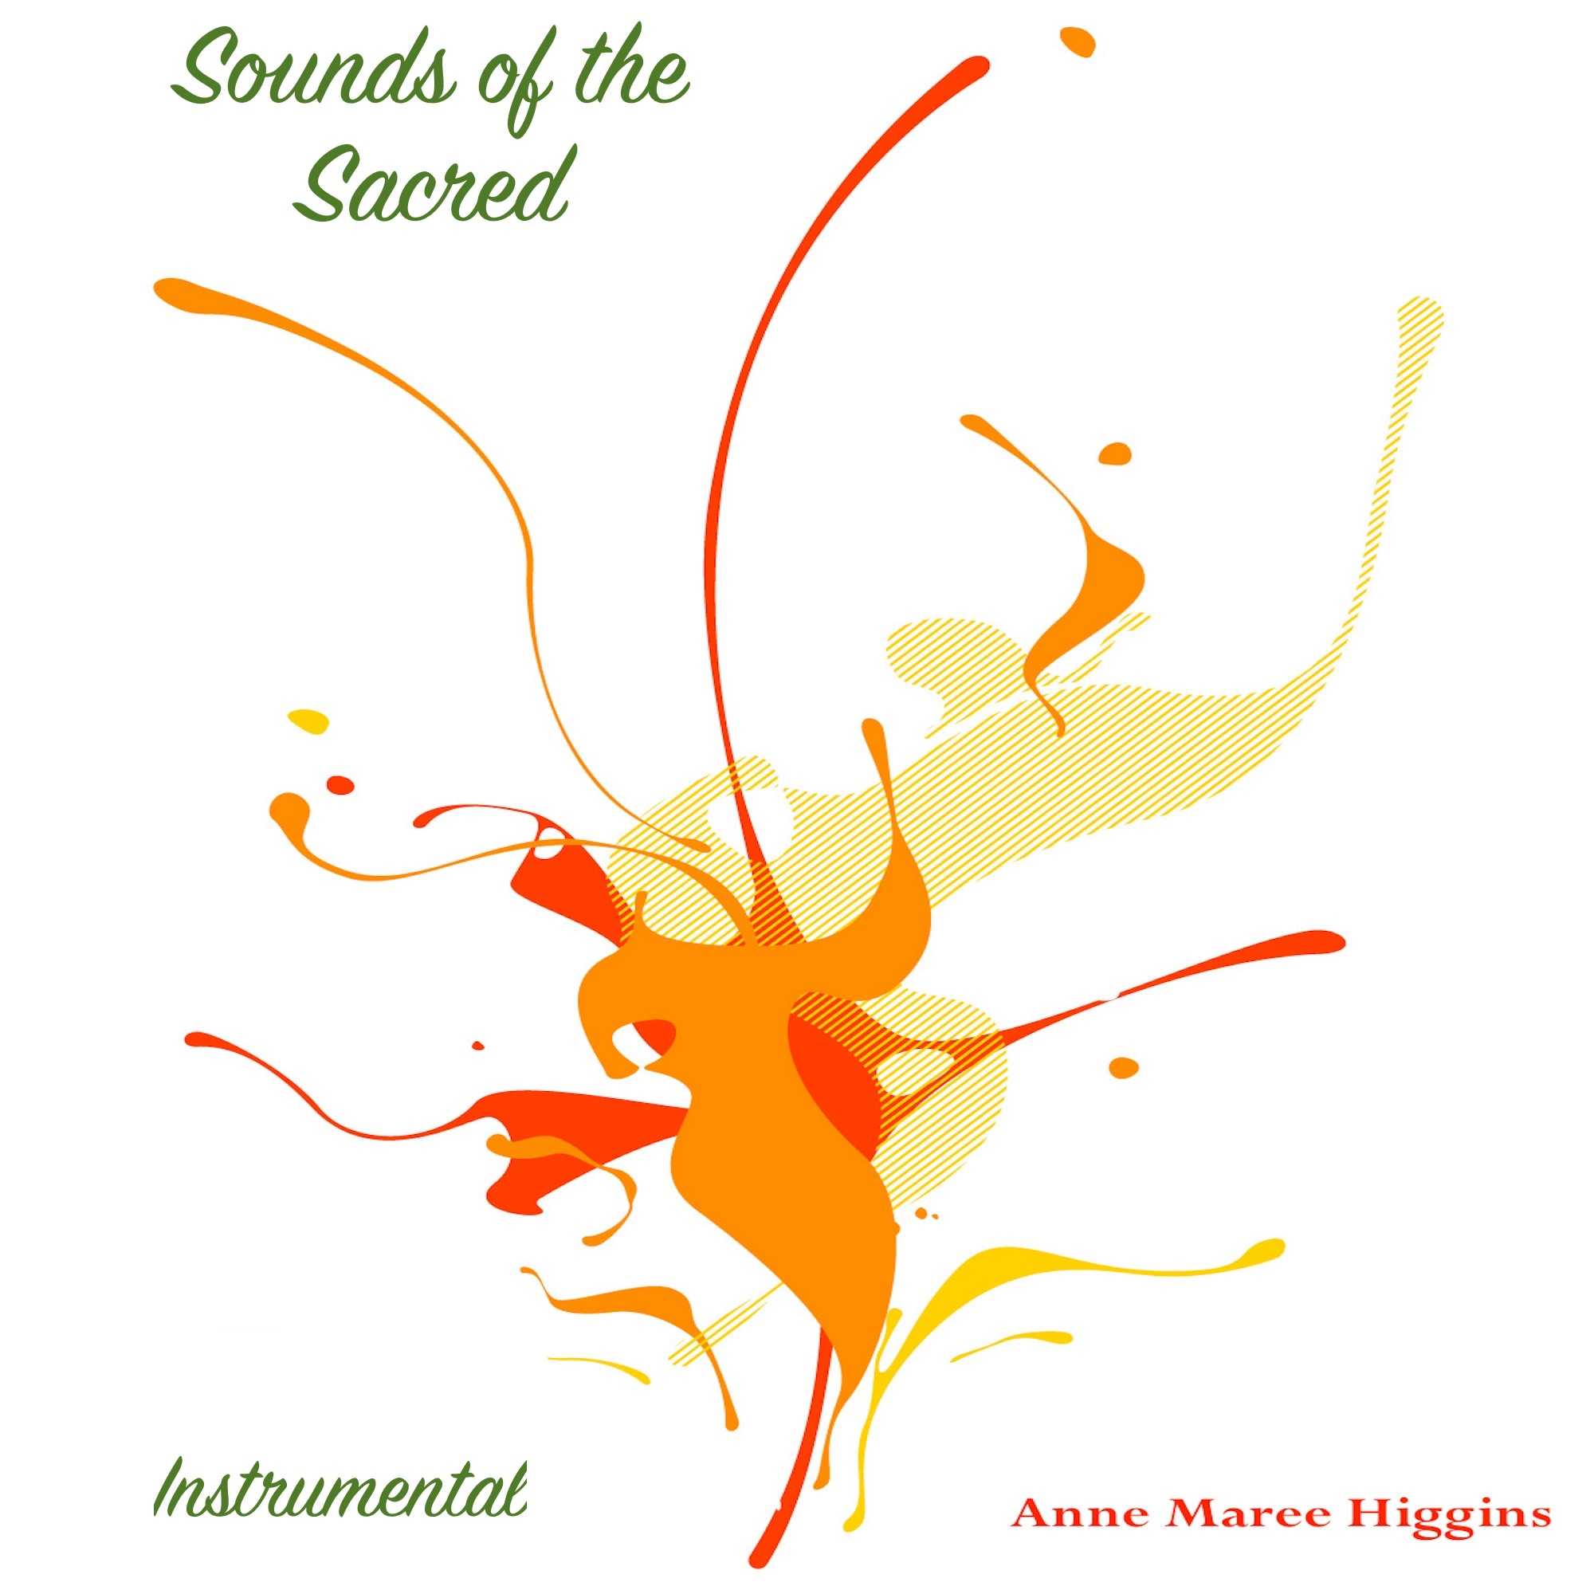look for this image

This section of the reading could be dramatically expressed using 2 Wooden Sticks or your Message Stick

Reader: The Creator spoke to me again. He said, "Take this Wooden stick and write on it this message: “The Clans from this 'side of the river'. Then take another stick and
write on it the message, ‘The Clans from the other side of the river.' Then hold the two sticks end to end in your hand so that they look like one."

"When the people ask you to tell them what this means, tell them that I, the Creator, am going to take the stick representing the Clans from this side of the river and put it with the one representing the Clans from the other side of the river. Out of the two I will make one stick and bring you back to the one nation you were."

"Hold in your hand the two sticks and let the Clans see them. Then tell them that I, the Creator Spirit, will take all my people who have been displaced, gather them together and bring them back to their own land. I will unite them as one people in the land that was once theirs. They will live there forever, so will their children and all their descendents. I will establish them and increase their population. I will live there with them for I am their Creator and they are my People."

These words are based on the Word of the great Prophet EZEKIEL:

All: THANKS BE TO GOD

A reflection on the word: By his death and reappearance, Mungo Man has revealed to us that deep spirit connection his people had with the earth. It is one repeated today with his Aboriginal descendants in their "Connection to Country". In a striking example of death and the emergence of Mungo Man, the spirit energies active in this ritual challenge us to reflect on that other death that other death and resurrection 36,000 years later. For a moment, let us respectfully consider points of similarity between the death of Mungo Man and the death of Jesus.

The nature and occasion of those two deaths were very significant, although separated by time and place; those events on the shores of Lake Mungo resonate with those in Jerusalem.

With the spirit messages of Christ expressed in his frequent parables of the Earth, the connections revealed by Mungo Man with nature both reflect that deep spirit connection between the divine and the earth, our Mother. Like Christ’s, teachings that ritual death of Mungo Man reflects a deep spirit bond with the world, with the sand, the soils, the plants and animals that we take so much for granted. The spirit-bond establishes a sacred status between people and earth, between nature and culture. The earth from which we came, takes on its special spirit significance. In union with Mungo Man we can say the world around us, from stars in the heavens to the rocks and plants on earth, all share in the sacred relationship with the divine. Confirmed by the Resurrection of Christ, this relationship was prefigured 38,000 years earlier. It speaks to us today in the re-emergence; from the death and burial of that man on Lake Mungo shores 40,000 years earlier.

Prayers of Intercession:
Reader: As a community, let us pray for our needs and the needs of our First Peoples:
Reader: Creator Spirit, we give thanks for the traditional owners who have worked tirelessly for this moment of peace and justice. May they be a source of hope and inspiration to future generations who will remember Mungo Man's story of loss and return.
Response: May the spirit of Mungo Man rest in peace
Reader: Creator Spirit, we pray that the injustices of taking Mungo Man away from country without permission from Traditional Owners will never happen again.
Response: May the spirit of Mungo Man rest in peace
Reader: Creator Spirit, we pray for the mourners at Mungo Man’s burial site as they in ceremony lay his body to rest.
Response: May the spirit of Mungo Man rest in peace.
Reader: Creator Spirit, we pray that all Australians will come to understand the importance of this story as a way of learning to love the land which is embracing and shaping them.
Response: May the spirit of Mungo Man rest in peace.
Reader: His life and death were sacred, by the ritual of his burial, he and his community acknowledged their links with nature, with the sun, with the stars, with the Cosmos itself.
The ochre, that blood red symbol of life signaled a connection to something beyond everyday humanity. It spoke then and speaks today of a direct spirit-link with the Earth from which it came.

Reader: Let’s us close our eyes take a moment to notice the gentle rhythm of our own breathing.
Inhaling….exhaling
Inhaling….exhaling
Let us stand now and offer a minute’s silence unified in spirit with the Elders as they receive their Ancestor home.

One minute of silence
May the spirit of Mungo Man rest in peace
AMEN
Then play
Final Song
‘Travelling Bones” by Archie Roach play first 2mintues only
https://www.youtube.com/watch?v=U5Gb250jisQ

Abstract of ‘What is Sacred” written by: Prof Jim Bowler has been woven into this liturgy with permission.

